**Interview Analysis**

**Prepared By**

**Umang Agarwal**

Problem Statement:

To develop an Interview Analysis system which will analyze the performance of candidates in quiz. There are two entities Admin and Candidate.

* Candidate /Admin can login through the app.
* Admin should asign quiz for candidates.
* Create multiple questions on different topics with answer.
* Candidate should be provided with sets of MCQ questions.
* Candidate should be able to answer the questions.
* Once done, all the answers should be submitted.
* Provide varies graph to show the result (like graph on each section, graph on topics, etc.)

Scope:

User: Admin, Candidate

Admin: login, add test, remove test, update test, delete test, add questions, assign test

User: Login, Give Test, Get Results

Out of Scope

Rendering fusion charts with dynamic data

Classes:

1. User

2. Test

3. Questions

Attributes:

1. User

a. userId : Long

b. userName : String

c. userTest : Test

d. isAdmin : Boolean

e. userPassword : String

2. Test

a. testId : BigInteger

b. testTitle : String

c. testDuration : LocalTime

d. testQuestions : Set<Question>

e. testTotalMarks : BigDecimal

f. testMarksScored : BigDecimal

g. currentQuestion: Question

h. startTime: LocalDateTime

i. endTime: LocalDateTime

3. Questions

a. questionId : BigInteger

b. questionOptions : Array<String>

c. questionTitle : String

d. questionAnswer : Integer

e. questionMarks : BigDecimal

f. chosenAnswer : Integer

g. marksScored : BigDecimal

Diagrams:

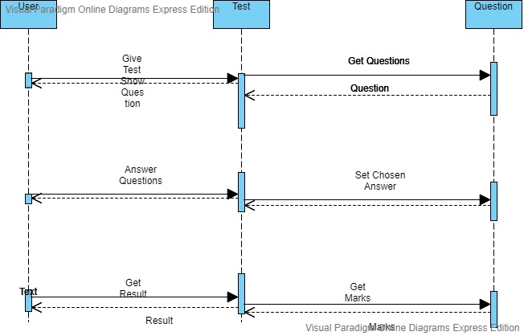

Sequence Diagram

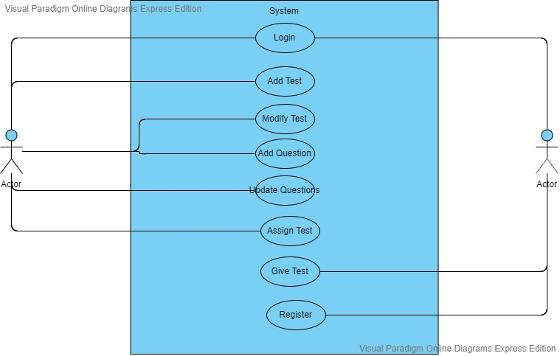

Use Case Diagram

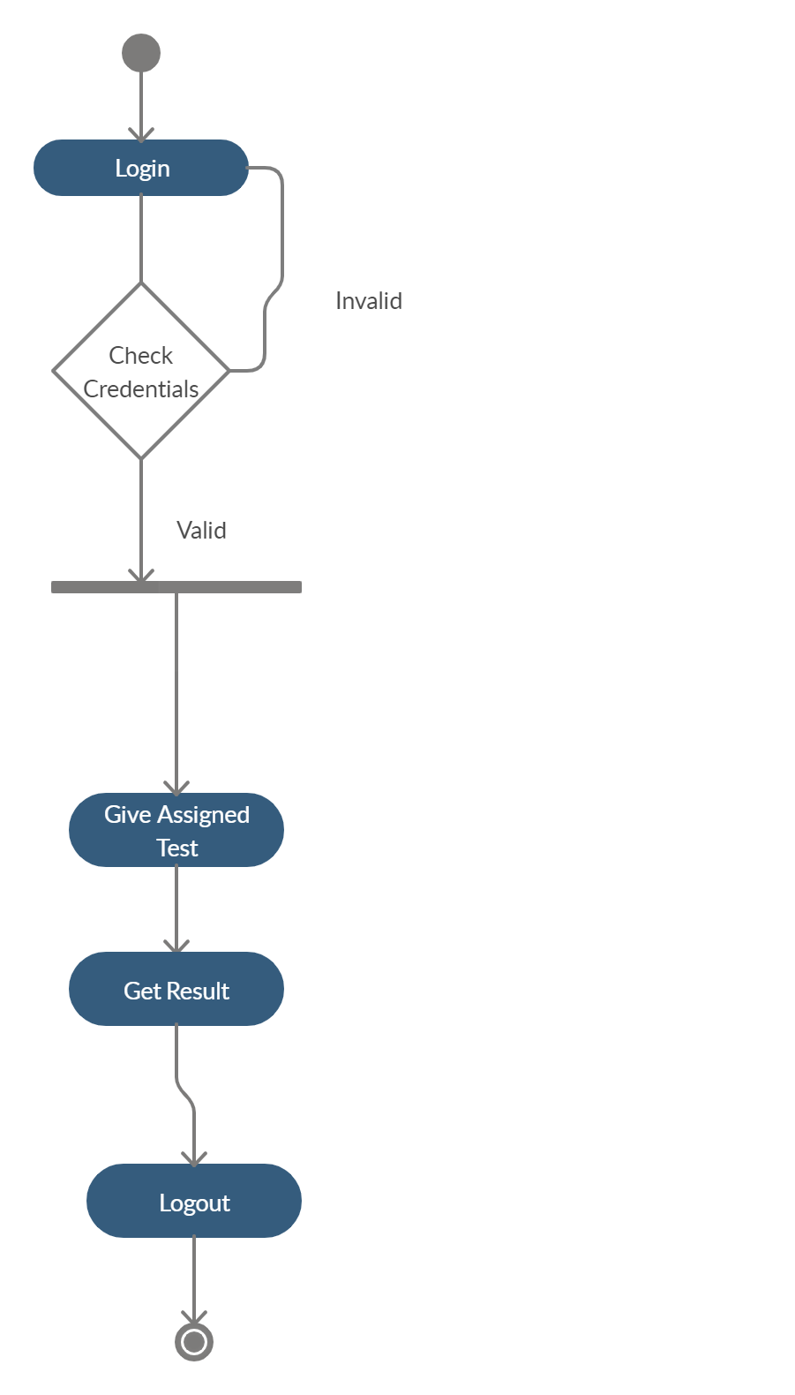

Activity Diagram for User

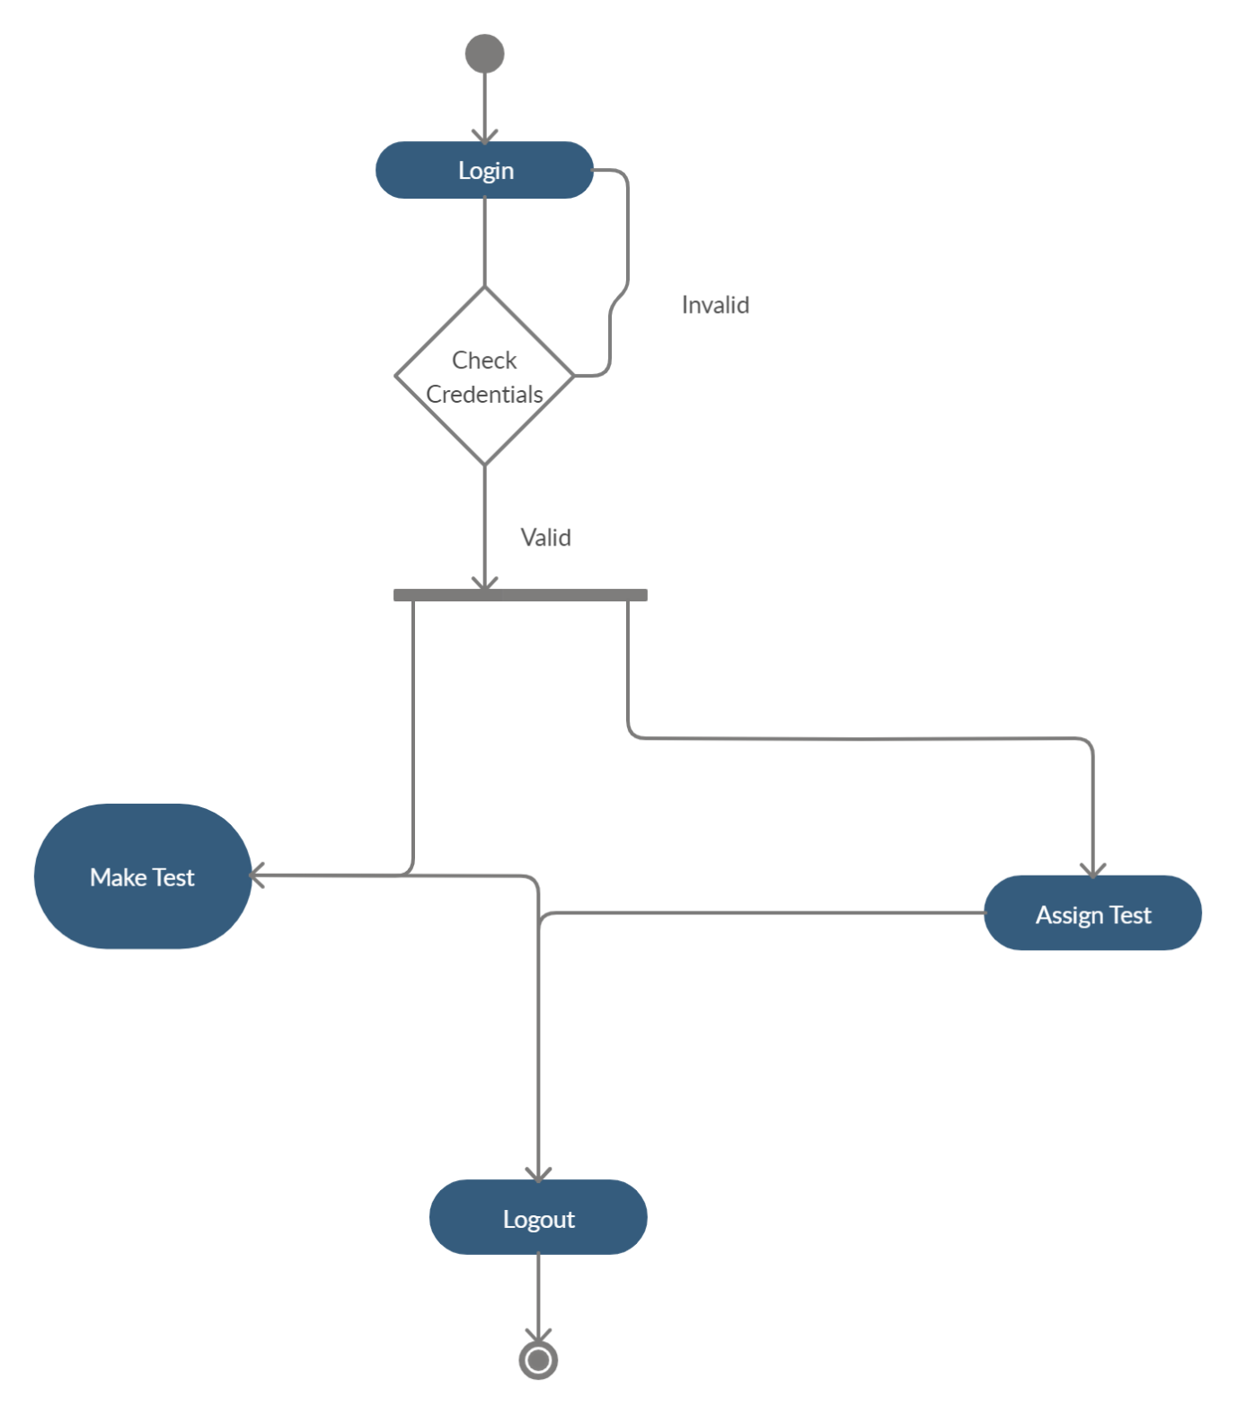

Activity Diagram for Admin

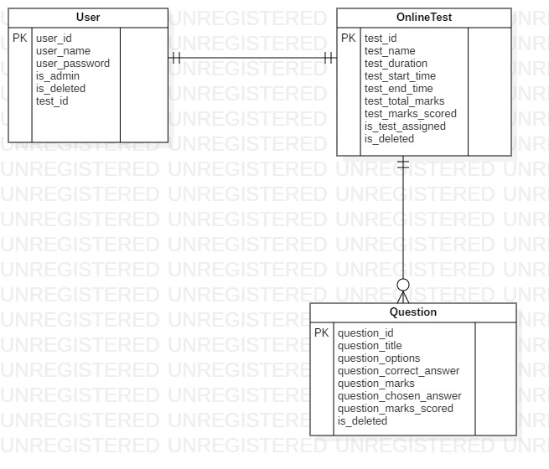

ER Diagram

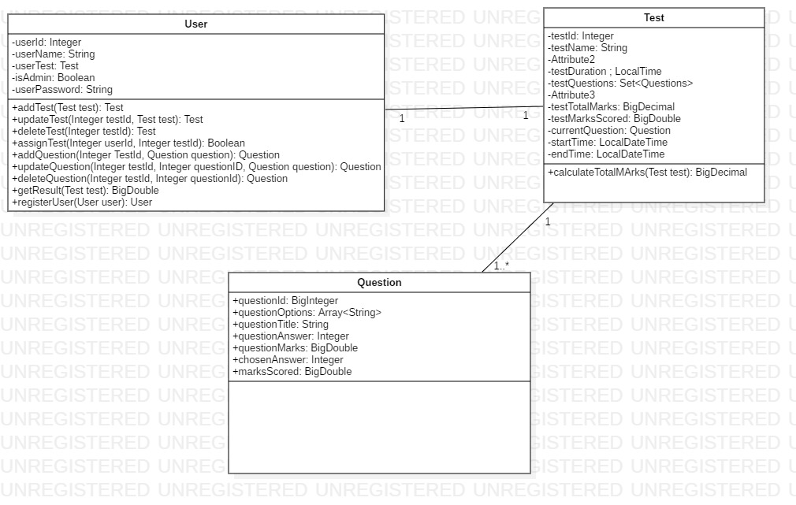

Class Diagram

Methods:

1.User

1.1. addTest(Test test) : Test

If the user is an admin, then only he can add the test. There are two ways to add test : Add through excel or add one by one using the interface.

1.2. updateTest(in BigInteger testId, in Test test): Test

If the user is an admin, then only he can update the test. He can update or delete the test using the interface and can add test using the interface as well as excel.

1.3. deleteTest(in BigInteger TestId): Test

If the user is an admin, then only he can delete the test. This method will delete the test along with all the questions inside it as well.

1.4. assignTest(in Long userId, in BigInteger TestId):

If the user is an admin, then he can assign a particular test to a user.

1.5. addQuestions(BigInteger TestId,Question question):

Question

This method will be called whenever the admin wants to add a question into a test.

1.6. updateQuestions(BigInteger TestId,Question question) :

Question

This method is called whenever the admin wants to update a question in the given test. It will return null if the question doesn’t exist in the test.

1.7. deleteQuestions(BigInteger TestId,Question question) :

Question

This method is called whenever the admin wants to delete a question in the given test. It will return null if the question doesn’t exist in the test.

1.8. getResult(Test test): BigDecimal

If the user is a student, he can use this method to get the total marks scored by them in the test assigned to them.

2.Test

2.1. calculateTotalMarks(): BigDecimal

This method is called whenever the user completes a test. This method will calculate the sum of the marks obtained by the student in each question and store them in the testTotalMarks attribute.

Validations -

1. userId, testId, questionId should not be null.
2. testName cannot be null.
3. userName must not be null and its length must be between 3 and 15 characters long.
4. userPassword should have at least 6 characters
5. startTime should not be after endTime.

Technology Stack

1. **JAVA Track:**

* Java 8
* Angular 6+
* Maven
* Spring Boot 2.x
* SpringREST
* Spring Data JPA
* Postman

1. **.NET Track**

* Angular 6+
* SQL/MySQL/Oracle/Postgres